Multidirectional artificial selection experiment in a wild rodent, the bank vole: mimicking an adaptive radiation
Paweł Koteja¹, Katarzyna M. Chrząścik¹, Geoffrey Dheyongera², Agata Kołodziejczyk¹, Uttaran Maiti¹, Ewa Prawdzik¹, Agata Rudolf¹, Julia Wyszkowska¹, and Edyta T. Sadowska¹
¹Jagiellonian University, Poland; ²Ministry of Agriculture, Animal Industry and Fisheries, Uganda; pawel.koteja@uj.edu.pl
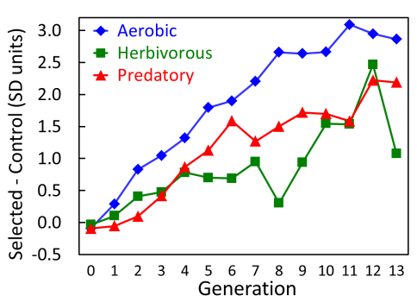
A central question in evolutionary physiology is how complex physiological adaptations evolve in response to natural selection operating on performance traits hypothetically associated with Darwinian fitness. Experimental evolution offers a powerful approach to test hypotheses concerning the correlated evolution of behavioural and physiological traits, which can underlie evolution of complex adaptations. We established a selection experiment with lines of bank voles Myodes (=Clethrionomys) glareolus selected in three distinct directions: high swim-induced aerobic metabolism (A), the ability to cope with a low-quality herbivorous diet (H), and intensity of predatory behaviour towards crickets (P). Four replicate lines are maintained in each of the selection directions and unselected control (C). Significant differences between the selected and control lines appeared already after three generations of selection. In generation 13, voles from the selected lines achieved 48% higher maximum rate of metabolism (A lines), lost 38% less body mass in the 3-day test with low-quality diet (H lines), and attacked crickets 5 times more frequently (P lines), than voles from the unselected C lines (Figure). We observed several correlated responses to selection in behavioral, morphological, physiological and life history traits. The selected lines provide a unique model to study genetic correlations between the physiological and behavioural traits, as well as cellular, biochemical and molecular factors underlying changes of the traits observed at phenotypic organismal level.
Figure: Cumulative effects of selection, measured as the difference between means of the selected and control lines, in units of phenotypic standard deviation.

